**SOL Review Topic 4: Solving Equations and Inequalities**

Absolute Value Equations, Rational Equations, Radical Equations, Quadratics, Systems, Inequalities

Absolute Value Equations

1)  2) 

Absolute Value Inequalities

3)  4) 

Radical and Rational Exponent Equations

5)  6) 

Rational Equations

7)  8)  9) 

Systems

Solve the system and state the number of solutions to the system.

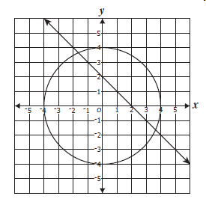10) 11) 

Quadratics

Solve and describe the nature of the roots.

12)  13)  14) 