Transformation Equations

For each of the following, name the function and the vertex (or pivot point). Then give the equation of the function after it has been shifted right by three and down 2.

11)  12)  13) 

Name: _____________ Name: _____________ Name: _____________

Vertex: _____________ Vertex: _____________ Vertex: _____________

Translated Equation: Translated Equation: Translated Equation:

  

14)  15)  16) 

Name: _____________ Name: _____________ Name: _____________

Vertex: _____________ Vertex: _____________ Vertex: _____________

Translated Equation: Translated Equation: Translated Equation:

  

Domain, Range, Increasing Decreasing

For each of the following, determine the domain, range, intervals to which the function is increasing and decreasing, is sign of the leading coefficient and the end behavior.

17) 18)

Domain: __________________ Domain: __________________

Range: ___________________ Range: ___________________

Increasing: ________________ Increasing: ________________

Decreasing: _______________ Decreasing: _______________

As As

As As

Leading Coefficient: __________ Leading Coefficient: _________

Factors: ________________

Possible Equation: _________________

Asymptotes

Find all asymptotes of the following functions.

19)  20)  21) 

22)  23)  24) 

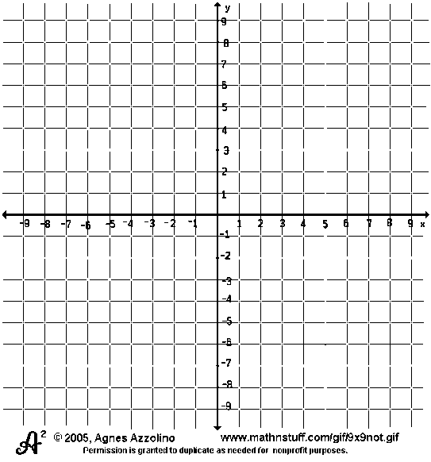

Inequalities

Graph the following inequality:

25) 

Zeros: Find  for the following functions. Name the # of real and imaginary solutions & degree.

Remember ’s = x-intercepts = zeros = solutions = roots.

26) 27)

= _______________ = _______________

# of Real Solutions = _____ # of Real Solutions = _____

# of Imaginary Solutions = _____ # of Imaginary Solutions = _____

Degree of Function: ______ Degree of Function: ______