

Solve the following Quadratics:

Solving Quadratics

What are the different ways to solve quadratics?

**#1 – Solve by Factoring**

19)  20)  21) 

**#2 – Solve by Graphing**

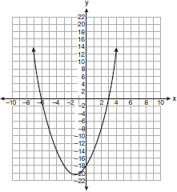22)

**#3 – Solve by Completing the Square**

23) 

**#4 – Solve by the Quadratic Formula** 

24)  25) 